National University of Computer and Emerging Sciences



Lab Manual # 7

Programming Fundamentals Lab

| Course Instructor | Ms. Arooj khalil |
| --- | --- |
| Lab Instructor(s) | Ms. Kissa Tanvir  Mr. Zaeem yousuf |
| Section | BCS-1B |
| Semester | Fall 2023 |

**Department of Computer Science**

FAST-NU, Lahore, Pakistan

**Objectives:**

In this lab, students will practice:

* Conditional structure
* While loop
* For loop
* Nested loops

**Questions:**

1. Print the square roots of the first 25 odd positive integers.
2. Write a program that inputs a number from the user and displays its factorial. It asks the user whether user wants to calculate another factorial or not. If the users inputs 1, it again inputs number and calculate another factorial. If the user inputs 0, the program terminates.
3. Write a program that gets two numbers from the user and displays the result of first number raised to the power of second number using do-while loop.

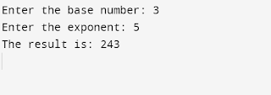

1. Write a program that inputs table number and length of table and then displays the table using for loop.

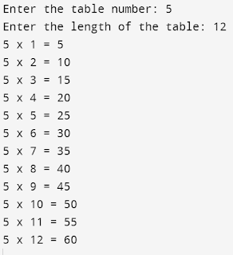

1. Write a program that calculates the occupancy rate for a hotel. The program should start by asking the user how many floors the hotel has. A loop should then iterate once for each floor. In each iteration, the loop should ask the user for the number of rooms on the floor and how many of them are occupied. After all the iterations, the program should display how many rooms the hotel has, how many of them are occupied, how many are unoccupied, and the percentage of rooms that are occupied. The percentage may be calculated by dividing the number of rooms occupied by the number of rooms.

**NOTE:** It is traditional that most hotels do not have a thirteenth floor. The loop in this. program should skip the entire thirteenth iteration.

1. Write a program that displays the following using do-while loop.**Ask user for starting and ending point.**

4 4 4 4

3 3 3

2 2

1

1. Write a program that finds the sum of the squares of integers from 1 to n. Where n is a positive value entered by the user, also display the series.

 i.e., **12 + 22 + 32 + …… + n2**. 



1. Write a program to display the following output using nested for loop:

**= = = = = ==   = = = = = ==  = = = = = ==**

**=                                                                       =**

**=                                                                       =**

**=                                                                       =**

**=                                                                       =**

**=                                                                       =**

**=                                                                       =**

**=                                                                       =**

**= = = = = ==   = = = = = ==  = = = = = ==**

1. Write a C++ program that calculates the sum of all elements in an integer array.
2. Create a C++ program that reverses the order of elements in an integer array. For example, if the original array is {1, 2, 3, 4, 5}, the reversed array should be {5, 4, 3, 2, 1}.